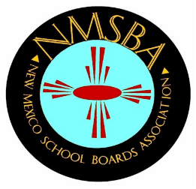

# 24 Year Service Award

## **Criteria for Judging Award**

24 years of Service (not necessarily consecutive) on the local school board.

Successful candidates must receive a positive vote from two-thirds majority of the voting Board of Directors. There will be no competition between 24 Year Service Award nominees.

### Nomination Form

Nominee Name: ______________________________________________

Nominee Address: ______________________________________________

______________________________________________

Please submit:

1. Letter of nomination outlining the board member’s accomplishments
2. Brief resume of the board member
3. Photo of the board member
4. Any other supporting documents

Nominator Name: _____________________________________________

Nominator School District: ______________________________________

Submit your nomination package via email to Lorraine Vigil, NMSBA Program Director at [lvigil@nmsba.org](mailto:lvigil@nmsba.org) or mail to:

New Mexico School Boards Association

300 Galisteo Street, Suite 204

Santa Fe, NM 87501

Fax (505) 983-2450

#### Deadline for Submission: Friday, September 20, 2024